**Plagiarism detection**

**Dondula Yashasvini**

**UG Student , Department of CSE , Sreendhi Institute Of Science And Technology**

**Abstract**

**Introduction**

Plagiarism, the act of using someone else's work without proper attribution or permission, is a serious issue in academic, professional, and creative spheres. With the increasing availability of digital content and ease of copying information, the need for effective plagiarism detection tools and techniques has become paramount. This report provides an overview and analysis of plagiarism detection, exploring various methods and technologies employed to identify and deter plagiarism.

**Types of Plagiarism**

Before delving into the detection methods, it is essential to understand the different types of plagiarism. They include:

a. Copying verbatim without attribution

b. Paraphrasing without proper citation

c. Self-plagiarism (reusing one's own work without acknowledgment)

d. Patchwriting (mixing original content with copied segments)

e. Collusion (working together to produce similar work without collaboration)

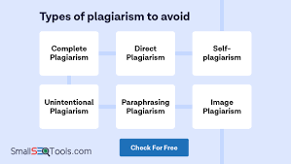

**Traditional Methods of Plagiarism Detection**

Historically, educators and content creators relied on manual methods to detect plagiarism. These involved comparing suspect documents against known sources or the writer's previous work. While effective to some extent, these methods were time-consuming, labor-intensive, and prone to human error.

**Technology-Based Plagiarism Detection**

Advancements in technology have revolutionized the field of plagiarism detection, offering faster, more accurate, and efficient methods. The following are some widely used technology-based approaches:

a. Text Comparison Algorithms: These algorithms analyse textual similarities between documents. They use techniques such as fingerprinting, shingling, and n-gram analysis to identify similarities in language, sentence structure, and word choice.

b. Machine Learning Techniques: Machine learning algorithms can be trained to detect patterns indicative of plagiarism. They can analyze large datasets and identify suspicious similarities, helping identify potential instances of plagiarism.

c. Document Metadata Analysis: Metadata analysis involves examining the metadata associated with a document, such as creation and modification dates, authorship information, and file history. Inconsistencies or anomalies in metadata can raise red flags for potential plagiarism.

d. Internet-Based Detection: Web-based plagiarism detection tools compare submitted content against a vast database of online sources, including academic journals, publications, websites, and student papers. These tools identify matching or highly similar content, assisting in the identification of potential plagiarism.

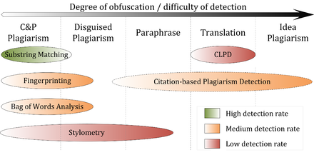

**Limitations and Challenges**

While plagiarism detection technologies have significantly improved, they still face certain limitations and challenges. Some of these include:

a. Evading Detection: Plagiarists may employ various techniques to evade detection, such as using synonym substitution, altering sentence structure, or translating content.

b. Cross-Language Plagiarism: Plagiarism detection across different languages poses challenges due to linguistic variations, cultural differences, and limited language-specific datasets.

c. False Positives and Negatives: Plagiarism detection tools may generate false positives, flagging legitimate content as plagiarized. Conversely, they may also miss instances of subtle plagiarism, leading to false negatives.

d. Privacy Concerns: Plagiarism detection often involves comparing submitted content against a vast database, raising concerns about data privacy and ownership.

**Best Practices and Prevention**

Alongside detection, preventive measures play a crucial role in combating plagiarism. Educational institutions, publishers, and content creators can implement the following best practices:

a. Education and Awareness: Educate students, authors, and content creators about the importance of academic integrity and proper citation practices.

b. Clear Guidelines: Provide clear guidelines on plagiarism, referencing, and citation methods to ensure individuals understand what constitutes plagiarism and how to avoid it.

c. Encourage Originality: Foster a culture of creativity and original thinking by emphasizing the value of unique ideas and insights

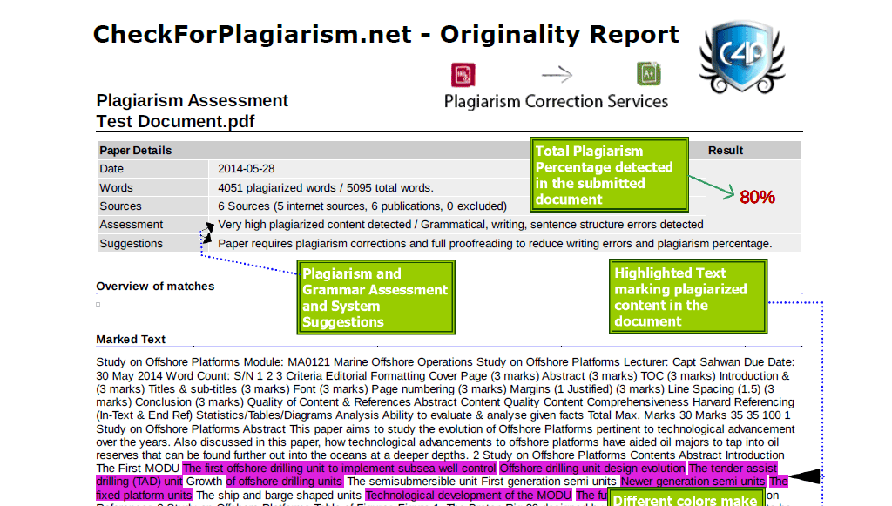

**Emerging Trends and Technologies**

Plagiarism detection continues to evolve with the emergence of new technologies and trends. Some notable advancements include:

a. Natural Language Processing (NLP): NLP techniques enable more sophisticated analysis of text, taking into account contextual and semantic information. This allows for improved detection of paraphrasing and subtle forms of plagiarism.

b. Authorship Attribution: Authorship attribution algorithms aim to identify the unique writing style of individuals, making it possible to detect cases where someone else may have written or contributed to a document.

c. Deep Learning: Deep learning models, such as convolutional neural networks (CNNs) and recurrent neural networks (RNNs), have shown promise in plagiarism detection. These models can learn complex patterns and representations in text data, enhancing the accuracy of detection.

d. Blockchain Technology: Blockchain has the potential to revolutionize plagiarism detection by providing a decentralized and tamper-proof platform for verifying the originality and ownership of content. By storing hashes or unique identifiers of documents on the blockchain, it becomes easier to track and verify sources.

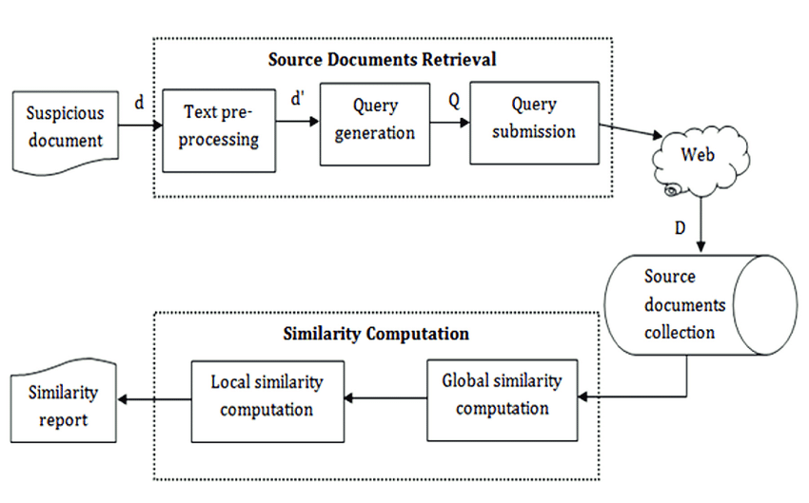

**Plagiarism Detection in Different Contexts**

Plagiarism detection is not limited to academia; it extends to various industries and contexts. Some specific applications include:

a. Academic Institutions: Educational institutions employ plagiarism detection tools to maintain academic integrity and ensure fair evaluation of students' work. Such tools are integrated into learning management systems and assist teachers in identifying instances of plagiarism in assignments, essays, and research papers.

b. Publishing Industry: Publishers and journal editors use plagiarism detection software to verify the originality of submitted manuscripts. This helps maintain the integrity of scholarly publications and prevent the dissemination of plagiarized content.

c. Online Content: Plagiarism detection is vital in combating the proliferation of duplicate and stolen content on the internet. Search engines and content hosting platforms employ algorithms to identify and penalize websites that publish plagiarized material.

d. Creative Industries: Plagiarism detection is also relevant in the creative industries, such as music and visual arts, to prevent unauthorized copying or imitation of original works.

**Ethical Considerations and Legal Implications**

Plagiarism detection raises ethical and legal considerations regarding privacy, intellectual property, and fair use. It is essential to strike a balance between protecting originality and respecting individuals' rights. Institutions and organizations must ensure that plagiarism detection processes adhere to relevant laws and policies while respecting individuals' privacy rights.

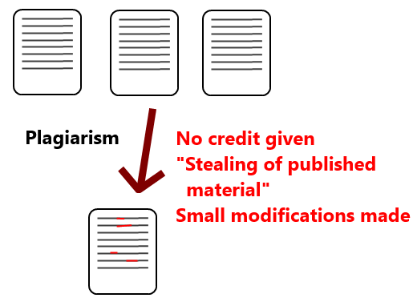

**Conclusion**

Plagiarism detection is a critical aspect of maintaining academic and professional integrity. The advancements in technology have significantly improved the accuracy and efficiency of detecting plagiarism. However, ongoing research and development are necessary to address the challenges posed by evolving plagiarism techniques. By combining effective detection methods with education and preventive measures, individuals and institutions can work towards fostering a culture of originality and academic honesty.